Roll No: 11135K
Principal: Mrs. Emer Magee
Chairperson BoM: Mrs. Amy Kidd
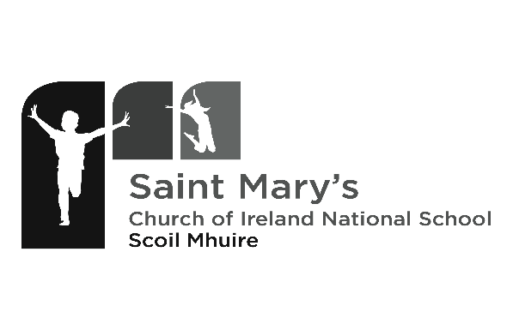
Phone/Fax: 059 972 1021
Email: secretary@stmarysnsbagenalstown.ie
www.stmarysnsbagenalstown.ie

NOTIFICATION OF INTENTION TO APPLY
This is not an application form and does not form part of the selection process. The school will make a record of parents wishing to enroll their child/ren for no other purpose than being in a position to post our application forms in the December before the September enrolment.

Child’s name

Date of Birth

Name of Father

Name of Mother

Full Postal Address and Eircode

Telephone Numbers | Home:  Father’s Mobile:  Mothers Mobile:
Email Address

Requested date of entry to school
I/We wish to give notice of our intention to apply for enrolment in respect of _________________
(applicant pupil) to St. Mary’s National School for Term ________ in school year _____________ in accordance with the foregoing information, and request that an application form be sent to me/us at the appropriate time.
I/We understand that this notification places the applicant pupil on a list of those requiring enrolment applications for the stated term and year. I/We understand that this notification does not offer any preferment to the applicant pupil and does not guarantee any place for him/her either for the term and year requested or for any other term or year.
I/We understand that it is our responsibility to communicate to the school any change in our circumstance address.

Signed: _______________________________________________ Date: ____________________

